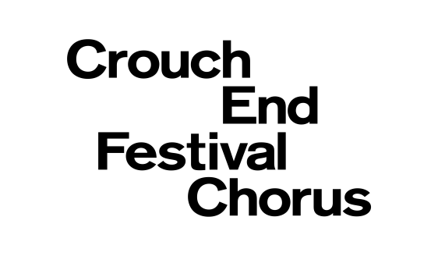  Crouch End Festival Chorus is a Registered Charity No. 1110790. Incorporated by guarantee in England No. 5052052  Registered Office: 18 Stanhope Gardens, London N4 1HT  JOIN OUR FRIENDS  Why not become a Friend of Crouch End Festival Chorus? As a much valued part of the family, you’ll help to support a choir which is firmly rooted in North London, and is widely acclaimed as one of the leading symphony choruses in the country.  Membership entitles you to:  - Regular newsletter with advance notice of concerts  - 20% discounts on tickets (bigger discounts for Young Friends)  - A free concert programme in which your name is acknowledged  - A free drink at the concert hospitality table  - Invitations to open rehearsals and social events  Subscription £25 (individual)/£40 (couple)/ £50 (family)/ £5 (Young Friend – under 18 or full-time student)  If you would like to buy a Gift subscription for someone else, please fill in their details on the middle section of this form and send with your cheque and a covering letter, saying who the gift is from and stating your own contact detail | APPLICATION FORM  I/we would like to join the Friends of CEFC  PLEASE WRITE IN CAPITALS  name(s) (as you wish them to appear in the programme)  _______________________________________________  address _______________________________________  _______________________________________________  postcode ______________________________________  telephone_________________________________________  email ____________________________________________  I am happy to receive communication by email (please tick): Yes No  Subscription £25 (individual)/£40 (couple)/ £50 (family)/ £5 (Young Friend)  *I/we have completed the attached standing order form OR  *I /we enclose a cheque payable to Crouch End Festival Chorus for:  The annual subscription of £___________________________  Any further kind donation of £___________________________  TOTAL £___________________________  GIFT AID DECLARATION (delete if not applicable)  I am a UK taxpayer and I want the above additional donation to be Gift Aided  signature _____________________________________________  date _____________________________________  Please return this form and any cheque to:  Ida Griffith, CEFC Friends Coordinator  12 The Meadway, Loughton IG10 3AN  friends@cefc.org.uk | PAYMENT BY STANDING ORDER  If you wish to pay your subscription by standing order please complete the form below and send to us.  To the Manager  Bank name ___________________________________  address_______________________________________  _______________________________________________  postcode_____________________________________  Please pay to Crouch End Festival Chorus  CAF Bank Ltd  PO Box 289  West Malling, Kent ME19 4TA  sort code: 40-52-40  account number : 00082804  Quoting ref* ____________________________CEFC-F *  Please insert your initials and surname  the sum of £__________________________________  amount in words _______________________________  on (date) ___________________________________  and thereafter every year until further notice.  account name________________________________  sort code _________________________________  account no _________________________________  PLEASE CANCEL ANY PREVIOUS STANDING ORDER IN FAVOUR OF CROUCH END FESTIVAL CHORUS  signature of account holder  ______________________________________________  date ________________________________________

